Matters for which a planning permit is required
East Gippsland Planning Scheme
Starting from 1 December 2024, there are revised forms for notices of planning permits and decisions that must be used by Council. When you apply for a permit, give notice of an application, or get a decision (an approval or refusal), the specific Planning Scheme matter(s) for which a planning permit is required must be mentioned.
How to Apply for a Permit:
- Understand what you want to do: Draft a proposal, sketch plan, concept business plan, or similar, to be clear of what you plan to do.
- Find your Zones and Overlays: Use a Property Planning Report to see what zones and overlays apply to your property. You can get this report from the Department of Transport and Planning Property and Parcel Search: https://www.land.vic.gov.au/maps-and-spatial/first-time-here/property-and-parcel-search
- Overlays Areas: If your proposal is not within the overlay area mapped to your land, you don't need a permit for that overlay.
- Particular Provisions: Your proposal might require a permit for another reason, such as signs, car parking reduction, liquor licence, or alternatively might have a performance requirement to be met (the scale of the business, for example).
- Get Advice: Some projects might not need a planning permit. It's best to ask an independent planning consultant or get written advice from the Council.
- Make the application: Refer to Council’s website for the appropriate forms.
Notice and Review Exemptions:
Some planning permits don't need to be publicly notified or reviewed by third parties. In the table below:
- Always exempt matters are marked with an asterisk (*).
- Conditionally exempt matters are marked with a plus (+).
VicSmart Applications:
If your application meets the 'VicSmart' criteria, it won't need public notice or third-party review.
Matters for which a permit is required
Throughout the assessment of your application, the ‘matters for which a permit is required’ will feature on documents such as public notice, and the decision made by Council. This is required by the Planning and Environment Regulations 2015 as amended 1 December 2024.
To ensure consistency, Council’s application forms are being updated to include an applicant’s declaration of which matters requiring a permit are sought by the application.
For an example, an application which proposes a two-lot subdivision and development of a second dwelling in Eagle Point is provided. The fictional property is covered by a bushfire management overlay and design and development overlay. In the past, the “description of the proposal” or “what the permit allows” would be the above description.
If you need assistance in filling in the “matters for which a permit is required” table, please call Council’s Planning Team on 03 5153 9500.
In the new forms, what is being proposed will appear in the following format (over):
Form 2 – Notice of an Application for Planning Permit
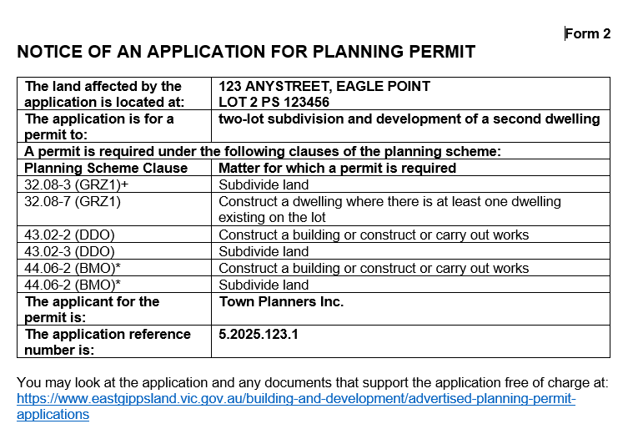

Form 4 – Planning Permit
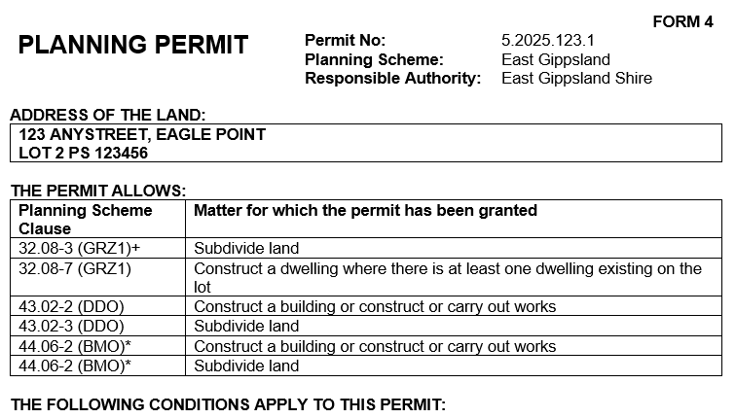
Matters for which a permit is required – full East Gippsland Planning Scheme
Within the East Gippsland Planning Scheme, the zones, overlays and particular provisions contain various permit requirements. This table provides the basic format of each permit requirement that will feature on documentation through the application process. This list does not include exemptions to where a permit is required, which are embedded within the Scheme. https://planning-schemes.app.planning.vic.gov.au/East%20Gippsland/ordinance
In the table below, wording in BLUE HIGHLIGHT are either variables in the wording (where the scheme language uses OR, or represent a placeholder for land use terms. The land use terms are outlined in Clause 73 of the East Gippsland Planning Scheme.
In the table below, wording in italics is necessary for interpretation of the control, but not required to be kept in the matter for which a permit is required list.
This information current as at 24 January 2025, and is subject to change based on amendments to the East Gippsland Planning Scheme.
Planning Scheme Clause | Matter for which a permit is required
ZONES
Low Density Residential Zone (LDRZ)
32.02-1 (LDRZ) | Use of land for INSERT USE
32.03-3 (LDRZ) | Subdivide land
32.03-4 (LDRZ) | Construct or carry out a building or works for INSERT USE
Mixed Use Zone (MUZ)
32.04-2 (MUZ) | Use the land for INSERT USE
32.04-4 (MUZ)* | Subdivide land
32.04-5 (MUZ) | Construct one dwelling on a lot less than 300 square metres
32.04-6 (MUZ) | Construct or extend a small second dwelling on a lot of less than 300 square metres.
32.04-7 (MUZ) | Construct two or more dwellings on a lot
32.04-7 (MUZ) | Construct a dwelling where there is at least one dwelling existing on the lot
32.04-7 (MUZ) | Extend a dwelling where there are two or more dwellings on the lot
32.04-7 (MUZ) | Construct or extend a dwelling that is on common property
32.04-7 (MUZ)+ | Construct or extend a residential building
32.04-7 (MUZ)+ | Construct or Extend a front fence associated with 2 or more dwellings on a lot or a residential building within 3 metres of a street exceeding maximum height of xx
32.04-10 (MUZ) | Construct a building and carry out works for a residential aged care facility
32.04-11 (MUZ) | Construct a building or construct or carry out works for a SECTION 2 USE
Township Zone (TZ)
32.05-2 (TZ) | Use of the land for INSERT USE
32.05-5 (TZ) | Subdivide land
32.05-6 (TZ) | Construct or extend one dwelling one on lot less than 300 square metres
32.05-6 (TZ) | Construct or extend a front fence associated with one dwelling on a lot less than 300 square metres within 3 metres of a street exceeding maximum height of xx
32.05-7 (TZ) | Construct or extend a small second dwelling on a lot of less than 300 square metres.
32.05-8 (TZ) | Construct two or more dwellings on a lot
32.05-8 (TZ) | Construct a dwelling where there is at least one dwelling existing on the lot
32.05-8 (TZ) | Extend a dwelling where there are two or more dwellings on the lot
32.05-8 (TZ) | Construct or extend a dwelling that is on common property
32.05-8 (TZ) | Construct or extend a residential building
32.05-8 (TZ) | Construct or extend a front fence associated with 2 or more dwellings on a lot or a residential building within 3 metres of a street exceeding maximum height of xx
32.05-10 (TZ) | Construct a building and carry out works for a residential aged care facility
32.05-11 (TZ) | Construct a building or construct or carry out works for a SECTION 2 USE
General Residential Zone 1 (GRZ1)
32.08-2 (GRZ1) | Use of the land for INSERT USE
32.08-3 (GRZ1)+ | Subdivide land
32.08-5 (GRZ1) | Construct one dwelling on a lot less than 300 square metres
32.08-5 (GRZ1) | Construct or extend a front fence associated with one dwelling on a lot less than 300 square metres within 3 metres of a street exceeding maximum height of xx
32.08-6 (GRZ1) | Construct or extend a small second dwelling on a lot of less than 300 square metres.
32.08-7 (GRZ1) | Construct two or more dwellings on a lot
32.08-7 (GRZ1) | Construct a dwelling where there is at least one dwelling existing on the lot
32.08-7 (GRZ1) | Construct or extend a dwelling that it is on common property
32.08-7 (GRZ1) | Extend a dwelling where there are two or more dwellings on the lot
32.08-7 (GRZ1)+ | Construct or extend a residential building
32.08-7 (GRZ1)+ | Construct or extend a front fence associated with 2 or more dwellings on a lot or a residential building within 3 metres of a street exceeding maximum height of xx
32.08-9 (GRZ1) | Construct a building and carry out works for a residential aged care facility
32.08-10 (GRZ1) | Construct a building or construct or carry out works for INSERT USE
Industrial Zone 1 (INZ1)
33.01-1 (INZ1) | Use of the land for INSERT USE
33.01-3 (INZ1)+ | Subdivide land
33.01-4 (INZ1)+ | Construct a building or construct or carry out works
Industrial Zone 3 (INZ3)
33.03-1 (INZ3) | Use of the land for INSERT USE
33.03-3 (INZ3)+ | Subdivide land
33.03-4 (INZ3) | Construct a building or construct or carry out works
Commercial 1 Zone (C1Z)
34.01-1 (C1Z) | Use of the land for INSERT USE
34.01-3 (C1Z)+ | Subdivide land
34.01-4 (C1Z)+ | Construct a building or construct or carry out works
Commercial 2 Zone (C2Z)
34.02-1 (C2Z) | Use of the land for INSERT USE
34.02-3 (C2Z)+ | Subdivide land
34.02-4 (C2Z)+ | Construct a building or construct or carry out works
Rural Living Zone (RLZ) (Schedules 1-5)
35.03-1 (RLZ) | Use of the land for INSERT USE
35.03-3 (RLZ) | Subdivide land
35.03-4 (RLZ) | Construct a building or carry out works associated with a SECTION 2 USE
35.03-4 (RLZ) | Carry out earthworks as specified in a schedule to the Rural Living Zone
35.03-4 (RLZ) | Construct a building within nominated setbacks
35.03-4 (RLZ) | Construct a building or carry out works associated with accommodation located within 500 metres from the nearest title boundary of land on which a work authority has been applied for or granted under the Mineral Resources (Sustainable Development) Act 1990.
Rural Conservation Zone (RCZ)
35.06-1 (RCZ) | Use of the land for INSERT USE
35.06-3 (RCZ) | Subdivide land
35.06-5 (RCZ) | Construct a building or carry out works associated with a SECTION 2 USE
35.06-5 (RCZ) | Carry out earthworks as specified in a schedule to the Rural Living Zone
35.06-5 (RCZ) | Construct a building within nominated setbacks
35.06-5 (RCZ) | Construct a building or carry out works associated with accommodation located within 500 metres from the nearest title boundary of land on which a work authority has been applied for or granted under the Mineral Resources (Sustainable Development) Act 1990.
Farming Zone (FZ) (Schedules 1-4)
35.07-1 (FZ) | Use of the land for INSERT USE
35.07-3 (FZ) | Subdivide land
35.07-4 (FZ) | Construct or carry out a building or works for use of a SECTION 2 USE
35.07-4 (FZ) | Carry out earthworks as specified in a schedule to the Rural Living Zone
35.07-4 (FZ) | Construct a building within nominated setbacks
35.07-4 (FZ) | Construct a building or carry out works associated with accommodation located within 500 metres from the nearest title boundary of land on which a work authority has been applied for or granted under the Mineral Resources (Sustainable Development) Act 1990.
35.07-4 (FZ) | Permanent or fixed feeding infrastructure for seasonal or supplementary feeding for grazing animal production constructed within 100 metres of a waterway, wetland or designated flood plain. ANDOR A dwelling not in the same ownership. ANDOR A residential or urban growth zone.
35.07-4 (FZ) | A building or works associated with accommodation located within one kilometre from the nearest title boundary of land subject to:  A permit for a wind energy facility; or An application for a permit for a wind energy facility; or An incorporated document approving a wind energy facility; or A proposed wind energy facility for which an action has been taken under section 8(1), 8(2), 8(3) or 8(4) of the Environment Effects Act 1978.
Public Use Zone (PUZ) (Schedules 1-7)
36.01-1 (PUZ) | Use of land for INSERT USE
36.01-2 (PUZ) | Construct a building or construct or carry out works for INSERT SECTION 2 USE.
36.01-2 (PUZ) | Subdivide land
Public Park and Recreation Zone (PPRZ)
36.02-1 (PPRZ) | Use of land for INSERT USE
36.02-2 (PPRZ) | Construct a building or construct or carry out works
36.02-2 (PPRZ)+ | Subdivide land
Public Conservation and Resource Zone (PCRZ)
36.03-1 (PCRZ) | Use of land for INSERT USE
36.03-2 (PCRZ) | Construct a building or construct or carry out works
36.03-2 (PCRZ)+ | Subdivide land
Transport Zone (TRZ) (Schedules 1-3)
36.04-1 (TRZ) | Use of land for INSERT USE
36.04-2 (TRZ) | Construct a building or construct or carry out works for INSERT SECTION 2 USE.
36.04-2 (TRZ) | Subdivide land
Special Use Zone (SUZ) (Schedules 1-4)
37.01-1 (SUZ)+ | Use of land for INSERT USE
37.01-3 (SUZ)+ | Subdivide land
37.01-4 (SUZ)+ | Construct a building or construct or carry out works
Comprehensive Development Zone (CDZ) (Schedule 1)
37.02-1 (CDZ)+ | Use of land for INSERT USE
37.02-3 (CDZ)+ | Subdivide land
37.02-4 (CDZ)+ | Construct a building or construct or carry out works
OVERLAYS
Environmental Significance Overlay (ESO) (Schedules 1-3, Schedule 1 has many sub-schedules)
42.01-2 (ESO)+ | Construct a building or construct or carry out works.
42.01-2 (ESO)+ | Construct a fence
42.01-2 (ESO)+ | Construct bicycle pathways and trail
42.01-2 (ESO)+ | Subdivide land
42.01-2 (ESO)+ | Remove, destroy or lop any vegetation, including dead vegetation.
Vegetation Protection Overlay (VPO) (Schedules 1-8)
42.02-2 (VPO) | Remove, destroy or lop vegetation
Significant Landscape Overlay (SLO) (Schedules 1-6)
42.03-2 (SLO) | Construct a building or construct or carry out works.
42.03-2 (SLO) | Construct a fence
42.03-2 (SLO) | Remove, destroy or lop vegetation
Heritage Overlay (HO) (many schedules – 1 per heritage place)
43.01-1 (HO) | Subdivide land.
43.01-1 (HO)+ | Demolish or remove a building.
43.01-1 (HO)+ | Construct a building or construct or carry out works
43.01-1 (HO)+ | Externally alter a building by structural work, rendering, sandblasting or in any other way.
43.01-1 (HO)* | Construct or display a sign.
43.01-1 (HO)+ | Externally paint a building if the schedule to this overlay specifies the heritage place as one where external paint controls apply.
43.01-1 (HO)+ | Externally paint an unpainted surface.
43.01-1 (HO)+ | Externally paint a building if the painting constitutes an advertisement.
43.01-1 (HO)* | Internally alter a building if the schedule to this overlay specifies the heritage place as one where internal alteration controls apply.
43.01-1 (HO)* | Carry out works, repairs and routine maintenance which change the appearance of a heritage place or which are not undertaken to the same details, specifications and materials.
43.01-1 (HO)+ | Remove, destroy or lop a tree if the schedule to this overlay specifies the heritage place as one where tree controls apply.
43.01-2 (HO) | Subdivide a heritage place which is included in the Victorian Heritage Register. This includes the subdivision or consolidation of land including any building or airspace
Design and Development Overlay (DDO) (Schedules 2, 4, 5-8, 10, 11)
43.02-2 (DDO) | Construct a building or construct or carry out works
43.02-2 (DDO) | Construct a fence (if specified)
43.02-3 (DDO) | Subdivide land
Incorporated Plan Overlay (IPO) (Schedule 1)
Note, there are requirements before a permit is granted, but no standalone permit requirements in the IPO.
Development Plan Overlay (DPO) (Schedules 1-5, 7-9)
Note, there are requirements before a permit is granted, but no standalone permit requirements in the DPO.
Erosion Management Overlay (EMO) (Schedule)
44.01-2 (EMO)* | Construct a building or construct or carry out works
44.01-3 (EMO)* | Remove, destroy or lop any vegetation
44.01-5 (EMO)* | Subdivide land
Salinity Management Overlay (SMO) (Schedule)
44.02-2 (SMO)* | Construct a building or construct or carry out works
44.02-3 (SMO)* | Subdivide land
44.02-4 (SMO)* | Remove, destroy or lop any vegetation
Land Subject to Inundation Overlay (LSIO) (Schedule)
44.04-2 (LSIO)* | Construct a building or construct or carry out works
44.04-3 (LSIO)* | Subdivide land
Bushfire Management Overlay (BMO) (Schedule 1 & 2)
44.06-2 (BMO)* | Construct a building or construct or carry out works
44.06-2 (BMO)* | Subdivide land
Public Acquisition Overlay (PAO)
45.01-1 (PAO)* | Use land for any Section 1 or Section 2 use in the zone
45.01-1 (PAO)* | Construct a building or construct or carry out works
45.01-1 (PAO)* | Damage, demolish or remove a building or works
45.01-1 (PAO)* | Damage, remove, destroy or lop any vegetation
45.01-1 (PAO)* | Subdivide land
Environmental Audit Overlay (EAO)
There is no specific permit requirement in the EAO, but the provision sets standards for sensitive land uses.
Restructure Overlay (RO) (Schedule)
45.05-1 (RO)* | Subdivide land
45.05-2 (RO)* | Construct or extend a dwelling or other building
Development Contribution Plan Overlay (DCPO) (Schedule)
Note, there are requirements before a permit is granted, but no standalone permit requirements in the DCPO.
Specific Control Overlay (SCO)
There are no permit requirements in the SCO. The Specific Control (Incorporated Document) may provide exemptions to other matters in the scheme.
PARTICULAR PROVISIONS
52.02 Easements, Restrictions and Reserves
52.02 | Proceeding under Section 23 of the Subdivision Act 1988 to create, vary or remove an easement or restriction or vary or remove a condition in the nature of an easement in a Crown grant.
52.02 | Proceeding under Section 24A of the Subdivision Act 1988. (reserves and other similar land)
52.02 | Proceeding under Section 36 of the Subdivision Act 1988 to acquire or remove an easement or remove a right of way.
52.05 Signs
52.05-2 | Construct or put up for display a SIGN TYPE FROM SECTION 2
52.06 Car Parking
52.06-3+ | Reduce the number of car parking spaces required to x from y
52.06-3+ | Provide some or all of the car parking spaces required on another site
52.06-3+ | Provide more than the maximum parking provision specified in a schedule to the parking overlay.
52.08 Earth and Energy Resources Industry
52.08-1 | Use and develop land for earth and energy resources industry (SPECIFY ACTIVITY)
52.11 Home Based Business
52.11-2 | A home based business which allows no more than three people who do not live in the dwelling to work in the business at any one time
52.11-2 | A home based business which has a floor area of xxx square metres (not exceeding 200 square metres or one-third of the net floor area of the dwelling, whichever is the lesser.
52.11-2 | A home based business which allows no more than one additional commercial vehicle (a commercial goods vehicle, commercial passenger vehicle or tow truck within the meaning of the Transport Act 1983), not exceeding two tonnes capacity and with or without a trailer registered to a resident of the dwelling, to be present at any time.
52.15 Heliport and Helicopter Landing Site
52.15-1 | To use or develop any land for a heliport or a helicopter landing site even if it is ancillary to another use on the land
52.16 Native Vegetation Precinct Plan
52.16-3 | Remove, destroy or lop native vegetation, including dead native vegetation
52.17 Native Vegetation
52.17-1 | Remove, destroy or lop native vegetation, including dead native vegetation
52.19 Telecommunications Facility
52.19-1+ | Construct a building or construct or carry out works for a telecommunications facility
52.21 Private Tennis Court
52.21-2+ | Construct, use or illuminate a private tennis court where the performance requirements specified in the Code of Practice - Private Tennis Court Development Revision 1 March 1999 are not met
52.21-2+ | Construct, use or illuminate a private tennis court where the land is in an Environmental Significance Overlay, a Vegetation Protection Overlay, a Significant Landscape Overlay, a Heritage Overlay, an Urban Floodway Zone, a Floodway Overlay or a Land Subject to Inundation Overlay and a permit is required to construct a building or construct or carry out works OR to remove, destroy, prune or lop a tree or vegetation.
52.25 Crematorium
52.25 | Develop and use a crematorium on land that is used for cemetery purposes
52.27 Licenced Premises
52.27 | Use land to sell or consume liquor
52.28 Gaming
52.28 | Install or use a gaming machine
52.29 Land adjacent to the principal road network
52.29-2* | Create or alter access to a road in a Transport Zone 2/Land in a Public Acquisition Overlay if a transport manager (other than a municipal council) is the acquiring authority and the acquisition is for the purpose of a road.
52.29-2* | Subdivide land adjacent to a road in a Transport Zone 2/Land in a Public Acquisition Overlay if a transport manager (other than a municipal council) is the acquiring authority and the acquisition is for the purpose of a road.
52.32 Wind Energy Facility
52.32-2 | Use and develop land for a wind energy facility
52.33 Post boxes and dry stone walls
52.33 | Demolish or remove a post box constructed before 1930.
52.33 | Demolish, remove or alter a dry stone wall constructed before 1940 on specified land
52.34 Bicycle Facilities
52.34-2* | Vary, reduce or waive any requirement of Clause 52.34-5 and Clause 52.34-6
63.05 (Existing Use) Section 2 and 3 Uses
63.05 | Building or works are constructed or carried out for a use in Section 2 or 3 of a zone for which an existing use right is established
63.08 (Existing Use) Alternative Use
63.08 | Use the land for an alternative use which does not comply with this scheme
63.10 (Existing Use) Damaged or destroyed buildings or works
63.10 | Continue an existing use, and to construct or carry out buildings or works
64.03 Subdivision of land in more than one zone
64.03 | Create one lot smaller than specified in the scheme where the lot is in more than one zone and cannot comply with the minimum lot area

